
Smart Retail Vision – AI Powered Autonomous Inventory Monitoring and Shelf Analytics
CASE STUDY ANALYSIS REPORT
Submitted in the partial fulfilment for the Course of
CSA1012- Software Engineering
to the award of the degree of
BACHELOR OF ENGINEERING
IN
Artificial Intelligence and Data Science
Submitted by
Ishwariya P (192524445)
Under the Supervision of
Dr C Anita Davamani

SIMATS ENGINEERING


Saveetha Institute of Medical and Technical Sciences
Chennai-602105

Table of Contents
S. NO | Contents | Page No.
1 | Executive Summary | 4
2 | Understanding the Problem | 4
3 | Stakeholder Analysis | 5
4 | Current System Analysis | 5
5 | Proposed Software Solution | 6
6 | Functional Requirements | 9
7 | Non-Functional Requirements | 9
8 | Software Engineering Principles | 10
9 | Innovative Features | 10
10 | Technology Stack | 11
11 | AI & Computer Vision Design | 12
12 | System Architecture | 12
13 | SDLC / Development Methodology | 14
14 | Expected Outcomes | 14
15 | Risks & Limitations | 15
16 | Future Enhancements | 15
17 | Conclusion | 15
18 | Bonus Content | 16
19 | References | 17

1. Executive Summary
SmartRetail Vision is an edge-AI-driven autonomous shelf monitoring platform that fuses computer vision, IoT sensor data, predictive analytics, and multi-agent orchestration to eliminate manual shelf audits. The system continuously observes shelf state through multi-angle cameras, weight sensors, RFID and BLE tags, reconciles conflicting signals through sensor fusion, and maintains a live Digital Twin of the store hierarchy (Store → Aisle → Shelf → Product). A multi-agent AI layer (Inventory, Shelf, Demand, Pricing, Supplier, Analytics, Manager agents) converts raw detections into actionable business intelligence — shortage prediction, automatic replenishment requests, shelf health scoring, and natural-language reporting for store managers. Processing is pushed to Jetson Orin/Coral edge devices to minimize latency, bandwidth cost, and privacy exposure, while cloud services handle forecasting, ERP/POS integration, and long-term analytics. The solution is designed to be modular, horizontally scalable across thousands of stores, and incrementally deployable — starting with a single high-traffic aisle pilot and expanding to full-store, multi-store rollouts with drone and robotic restocking as a future phase.

2. Understanding the Problem

2.1 Problem in Context
Modern organized retail operates on thin margins where shelf availability directly drives revenue. A product that is out of stock, misplaced, or hidden behind another item is functionally invisible to the customer even though it exists in warehouse inventory. Manual audits — a store associate walking aisles with a clipboard or handheld scanner — are performed at most 2-3 times a day, are labour-intensive, subjective, and cannot scale to hundreds of SKUs across dozens of aisles in real time.

2.2 Industry Background
Retail chains report that stockouts alone cause an estimated 4% of annual revenue loss globally, while overstocking ties up working capital and increases spoilage for perishables. Emerging computer-vision shelf-monitoring solutions (e.g., robotic shelf scanners, smart-camera pilots) demonstrate technical feasibility but remain expensive, cloud-dependent, and poorly integrated with backend ERP/POS systems — leaving a gap for an affordable, edge-first, fully integrated solution.

2.3 Why the Problem Exists
- Human audits are infrequent and error-prone, causing stale inventory data.
- Products are misplaced by customers, creating invisible stock (phantom inventory).
- No real-time linkage between physical shelf state and backend ERP/POS records.
- Demand spikes (festivals, weather, promotions) are not anticipated proactively.
- Existing CCTV systems are used for security only, not for analytics.

2.4 Business Impact
Direct revenue loss from stockouts, capital lock-in from overstock, increased labour cost for manual audits, customer dissatisfaction and brand erosion, and inefficient supplier replenishment cycles.

2.5 Objectives
Objective | Explanation
Automate shelf monitoring | Continuously detect stock levels without manual intervention.
Predict shortages | Use historical and contextual data to forecast stockouts before they occur.
Detect anomalies | Identify misplaced, expired, or damaged products automatically.
Improve replenishment | Trigger automatic restocking workflows synced with warehouse/ERP.
Integrate operations | Unify shelf, POS, ERP, and supplier systems into one data layer.

2.6 Scope
In-Scope: Shelf-level visual and sensor monitoring, stock/shelf-health analytics, shortage prediction, auto-replenishment requests, manager dashboard, agentic assistant, ERP/POS integration APIs.
Out-of-Scope: Physical robotic restocking hardware manufacturing, in-store checkout/billing logic, supply-chain logistics beyond the warehouse gate, and customer-facing mobile shopping apps (treated as future enhancements).

3. Stakeholder Analysis
Stakeholder | Role | Pain Point | Expectation/Benefit
Store Manager | Oversee shelf & inventory ops | Slow visibility into stock status | Real-time dashboards, reduced audit effort
Store Associate | Execute restocking | Manual, repetitive audit work | Automated task lists, less manual counting
Category/Inventory Analyst | Demand planning | Inaccurate, delayed data | Accurate predictive analytics
Warehouse/Supplier | Fulfil replenishment | Late/ambiguous restock requests | Auto-generated, precise replenishment orders
Customer | Purchase products | Products unavailable/hard to find | Higher product availability, better experience
IT/Ops Team | Maintain system | Integration complexity | Modular APIs, clear monitoring
Business Owner/Executive | Profitability & growth | Revenue loss from stockouts | Higher ROI, data-driven decisions
Major challenge across stakeholders: conflicting priorities between minimizing overstock cost (owner) and maximizing shelf availability (customer/manager) — resolved through the Prediction Engine balancing service-level targets against holding cost.

4. Current System Analysis

4.1 Current Workflow
Associate performs scheduled visual walk-through → notes shortages/misplacements manually or via handheld barcode scanner → updates POS/ERP with a lag of hours → warehouse manually reviews and dispatches replenishment.

4.2 Strengths, Weaknesses & Gaps
Aspect | Description
Strengths | Low technology dependency; simple to train staff
Weaknesses | Slow, subjective, error-prone, not scalable
Limitations | No continuous visibility; blind to off-hour stockouts
Root Causes | Absence of automated sensing at shelf level
Business Impact | Revenue loss, poor CX, inefficient labour allocation

5. Proposed Software Solution
The proposed architecture layers Edge Sensing → Stream Processing → AI/Agent Intelligence → Application/Integration → Presentation, ensuring each layer is independently scalable and replaceable (loose coupling).

Objectives and Core Combined Solution
The proposed system aims to transform traditional retail shelf monitoring into an intelligent, automated, and predictive platform. Its primary objective is to provide continuous visibility into shelf stock status, detect empty spaces, misplaced products, and low inventory conditions in real time, and support faster replenishment decisions. It also aims to reduce manual inspection effort, improve shelf compliance, increase product availability, and enhance customer satisfaction. Beyond detection, the system is designed to generate actionable insights for store managers, predict future stock shortages, and integrate smoothly with existing retail workflows such as inventory, warehouse, billing, and supplier systems.

To achieve these objectives, the solution combines multiple advanced technologies into one unified architecture. First, a Smart Shelf + IoT layer is used, where each shelf is equipped with smart cameras, weight sensors, RFID readers, and BLE devices. This sensor fusion approach improves accuracy because even if the camera fails to detect an item due to occlusion or poor lighting, the weight sensor or RFID can still confirm product removal or presence. Second, a Multi-Camera AI layer is introduced using top, front, and side cameras so that the system can eliminate blind spots and better detect products from different viewing angles. Third, an Edge AI layer processes data locally on devices such as Jetson Orin, Jetson Nano, or Coral TPU, reducing latency, improving privacy, and lowering cloud dependency.

The solution further includes a Digital Twin Retail Store, which creates a virtual replica of the store organized as Store → Aisle → Shelf → Product. This allows managers to monitor stock level, shelf health score, and product visibility in a 3D or structured digital view. Along with this, an Agentic AI Inventory Manager enables users to ask questions in natural language, such as “Which products are running out in Dairy?”, and receive instant analytical responses, reports, and recommendations. A Multi-Agent AI System can also be used, where separate agents handle inventory, shelf monitoring, demand forecasting, pricing, supplier communication, and analytics, making the system modular and highly intelligent.

Additional innovation comes from Predictive Inventory AI, which forecasts when shelves are likely to become empty using historical sales, customer traffic, seasonality, weather, and festival trends. The system also supports Customer Behavior Analytics through heatmaps, dwell-time analysis, and product interaction tracking to help retailers understand which shelves attract attention and which zones are underperforming. A Shelf Health Score can be generated for every shelf based on factors such as stock availability, arrangement, visibility, cleanliness, expiry status, and planogram compliance. To improve operational automation, an Auto Replenishment System can generate refill requests automatically and sync with warehouse or staff workflows. Supporting features such as OCR-Based Shelf Reading, Expiry Detection AI, Digital Shelf Passport, Explainable AI Dashboard, Robotics Integration, Voice AI Assistant, and AR Maintenance make the solution future-ready, practical, and highly innovative for modern retail environments.

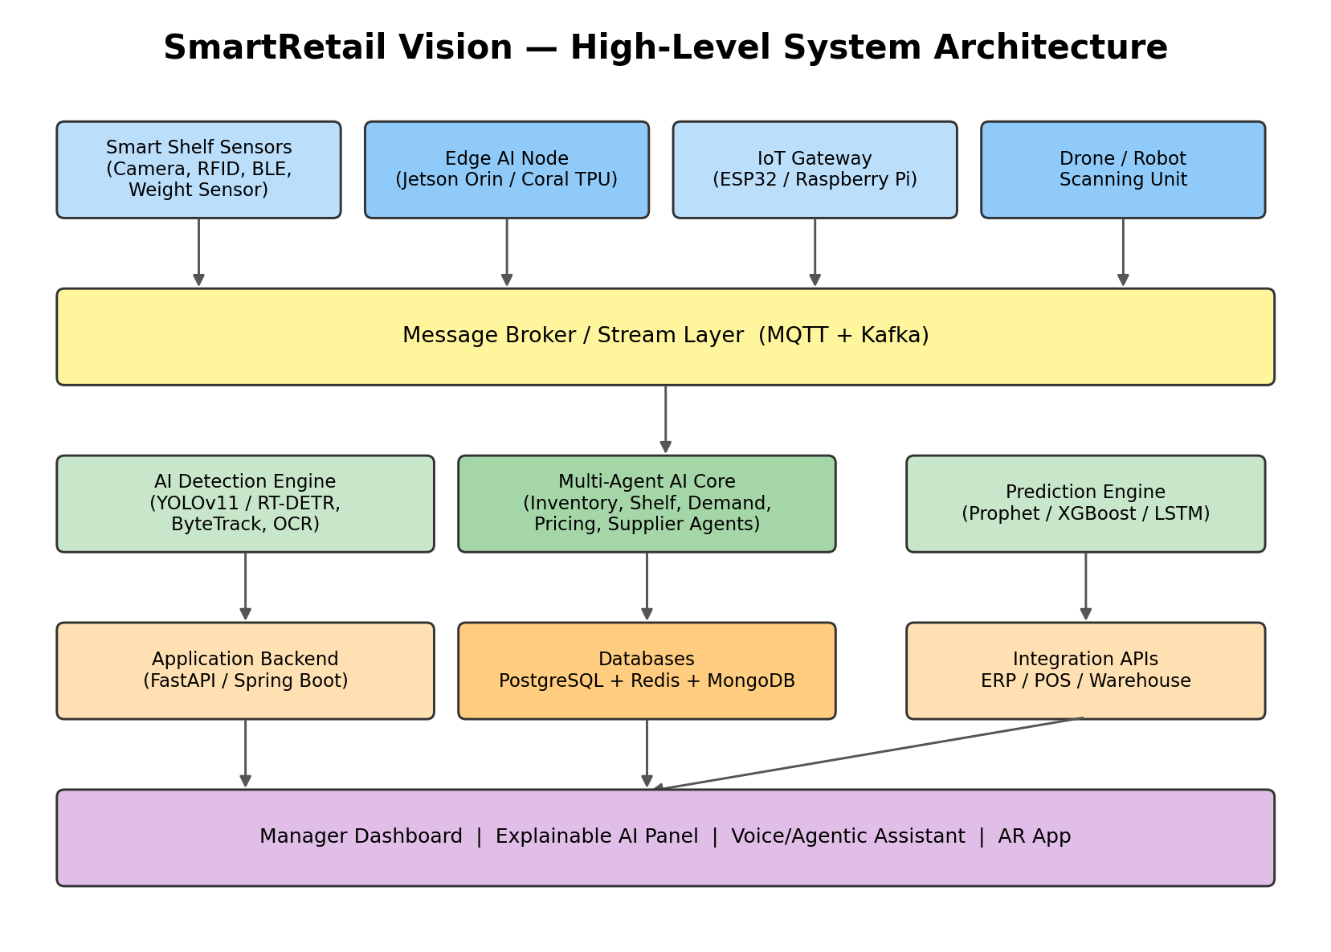

5.1 System Workflow

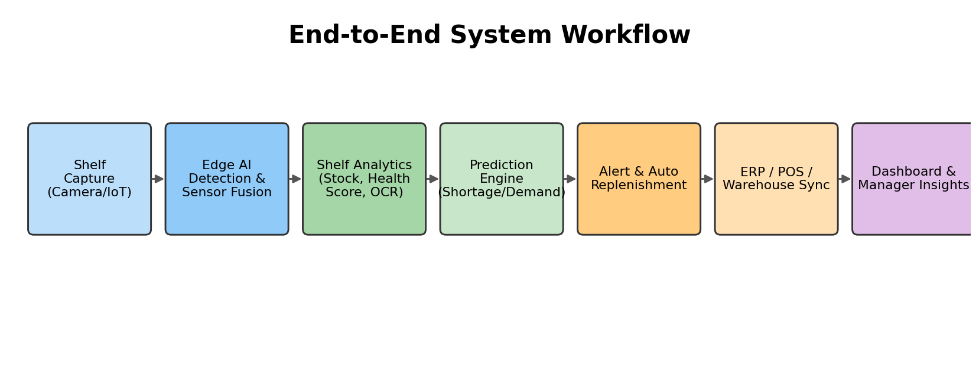

5.2 Core Software Modules

Module | Purpose | Input | Output | Tech | Advantage
User Management | Auth, roles for manager/associate/admin | Login, RBAC data | JWT sessions | FastAPI, PostgreSQL | Secure, role-based access
Camera & IoT Integration | Ingest sensor/camera streams | Raw frames, sensor readings | Normalized events | MQTT, ESP32 | Real-time, protocol-agnostic ingestion
Shelf Image Processing | Pre-process frames, stitch multi-camera views | Multi-cam frames | Cleaned frame set | OpenCV | Removes occlusion/blind spots
AI Detection Engine | Detect products, count, classify | Processed frames | Bounding boxes, SKU labels | YOLOv11, ByteTrack | High accuracy real-time detection
Shelf Analytics | Compute stock %, shelf health score | Detections | Shelf health score, visibility metrics | Python, Pandas | Actionable shelf-level insight
Prediction Engine | Forecast shortages/demand | Sales history, sensor trend | Shortage probability | Prophet, XGBoost | Proactive replenishment
Alert Management | Trigger notifications | Analytics events | Alerts to staff/ERP | Redis, WebSocket | Low-latency response
Dashboard | Visualize KPIs | Aggregated data | Charts, reports | React/Next.js, Grafana | Manager-friendly insight
Integration APIs | Sync with ERP/POS/Warehouse | Internal events | External system updates | REST/GraphQL | Unified operations
Security & Audit Logs | Protect & trace all actions | System events | Immutable audit trail | OAuth2, hash-chained logs | Compliance & traceability
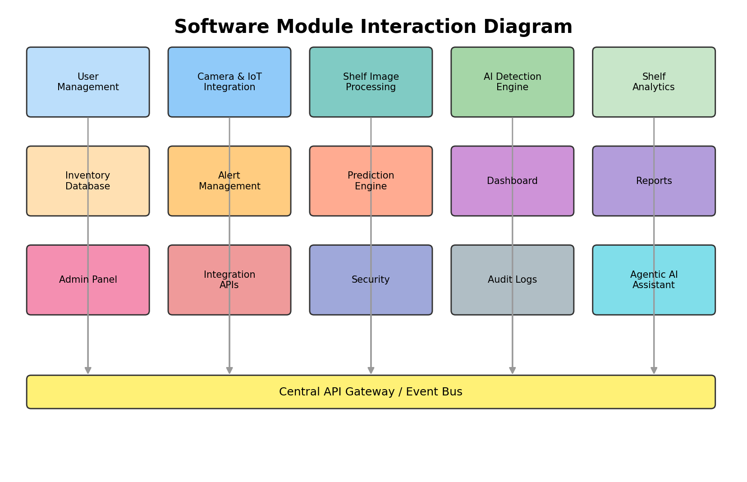

6. Functional Requirements

ID | Description | Priority
FR-01 | System shall detect product presence/absence on shelf in real time | High
FR-02 | System shall fuse camera, weight, and RFID data per shelf | High
FR-03 | System shall compute a Shelf Health Score (0-100) | High
FR-04 | System shall predict stockouts using historical & contextual data | High
FR-05 | System shall auto-generate replenishment requests | High
FR-06 | System shall detect near-expiry/expired/damaged products | Medium
FR-07 | System shall provide a natural-language assistant for managers | Medium
FR-08 | System shall sync with ERP/POS/Warehouse systems | High
FR-09 | System shall log all corrections for self-learning retraining | Medium
FR-10 | System shall generate explainable anomaly reports | Medium

7. Non-Functional Requirements
- Performance: Shelf state must refresh within seconds to reflect real customer activity.
- Security: Sensitive sales/customer data requires encryption and access control.
- Reliability: Retail operations run continuously; failures must not halt monitoring.
- Availability: 24/7 uptime required across all store hours including night restocking.
- Scalability: Must scale from one pilot aisle to thousands of stores.
- Maintainability: Modular codebase enables independent updates without downtime.
- Usability: Non-technical staff must operate the dashboard with minimal training.
- Accessibility: Dashboard must support screen readers and multiple languages.
- Privacy: Camera feeds must avoid unnecessary customer facial data retention.
- Portability: Deployable across cloud providers and on-prem edge hardware.
- Accuracy: Detection must minimize false positives to avoid wrong reordering.
- Compliance: Must align with data protection regulations (e.g., GDPR-equivalent).

8. Software Engineering Principles
- Modularity: Independent modules (Detection, Prediction, Dashboard) deployed as separate microservices.
- Scalability: Kubernetes horizontal pod autoscaling handles store/traffic growth.
- Maintainability: Clear module boundaries and API contracts simplify updates.
- Reusability: Detection/OCR pipelines reused across product categories and stores.
- Loose Coupling: Modules communicate via event bus (Kafka), not direct calls.
- High Cohesion: Each agent (Pricing, Supplier) owns a single well-defined responsibility.
- Reliability: Redundant sensor fusion prevents single point of detection failure.
- Security: OAuth2, RBAC, and encrypted channels protect data end-to-end.
- Fault Tolerance: Edge nodes cache and sync when cloud connectivity drops.
- Extensibility: New agents (e.g., Sustainability Agent) can be added without core changes.
- Performance: Edge inference minimizes round-trip latency to cloud.
- Testability: Each microservice independently unit/integration tested.
- Availability: Multi-zone cloud deployment with failover.
- Usability: Dashboard follows consistent, minimal UI design patterns.

9. Innovative Features

Feature | Problem Solved | Working | Benefit | Innovation | Difficulty
Digital Twin Store | Stockouts, poor visibility | Live 3D Store→Aisle→Shelf→Product model synced with sensor data | Instant visual diagnosis of any shelf | High | Medium
Multi-Agent AI Manager | Fragmented decision-making | Specialized agents collaborate via shared knowledge base | Faster, explainable decisions | High | High
Agentic Voice/NL Assistant | Slow manual reporting | Manager queries system in plain language | Zero-training reporting | High | Medium
Shelf Health Score | No unified shelf metric | Composite score from stock, cleanliness, visibility, expiry | Single KPI for shelf quality | Medium | Low
Auto Replenishment | Delayed restocking | AI auto-generates and routes replenishment orders | Reduced stockout duration | High | Medium
OCR Price/Label Reading | Manual price audits | PaddleOCR reads tags/discounts/expiry | Pricing accuracy, compliance | Medium | Medium
Self-Learning Loop | Static AI accuracy | Staff corrections feed retraining pipeline | Continuously improving accuracy | High | Medium
Explainable AI Dashboard | Black-box AI decisions | Every alert shows reasoning/evidence | Builds manager trust | Medium | Low

Additional roadmap-level innovations (digital shelf passport, drone inventory, AR maintenance overlays, robotics restocking) are detailed in Section 16 – Future Enhancements.

10. Technology Stack

Layer | Technology | Justification
Frontend | React / Next.js | Component reusability, SSR performance, strong ecosystem
Backend | FastAPI (Python) + Spring Boot (Java, enterprise modules) | Async I/O for AI workloads; Spring Boot for enterprise ERP integration
Database | PostgreSQL, Redis, MongoDB | Relational integrity + caching + flexible sensor-log storage
AI Detection | YOLOv11 / RT-DETR | Real-time, high-accuracy object detection
Tracking | ByteTrack / DeepSORT | Multi-frame product tracking to avoid double counting
OCR | PaddleOCR / TrOCR | Accurate label/price/expiry text extraction
Forecasting | Prophet, XGBoost, LSTM/TFT | Seasonal + non-linear demand prediction
Edge AI | Jetson Orin/Nano, Coral TPU | Low-latency, low-cost on-device inference
IoT | ESP32, RFID, BLE, weight sensors | Redundant, low-cost sensing fused with vision
Dashboard/BI | Grafana / Power BI | Real-time visual analytics for managers
Cloud | AWS / Azure / GCP | Elastic scaling, managed AI/ML services
Deployment | Docker, Kubernetes | Consistent, scalable microservice deployment
Monitoring | Prometheus, Grafana, ELK | Full-stack observability and log analysis
Agentic AI | LangGraph/LangChain + LLM API | Orchestrates multi-agent reasoning workflows

11. AI & Computer Vision Design

Model | Where Used | Justification
YOLOv11 | Real-time shelf product detection | Best speed/accuracy trade-off for edge deployment
RT-DETR | High-precision detection for dense shelves | Better on heavily occluded/cluttered scenes
Faster R-CNN | Benchmark/offline validation | High accuracy but too slow for real-time edge use
EfficientDet | Resource-constrained deployments | Good accuracy at lower compute than R-CNN
SAM (Segment Anything) | Precise shelf-region segmentation | Assists boundary detection for shelf-health scoring
OCR (PaddleOCR) | Reading price tags/labels/expiry | Purpose-built for dense small-text extraction

Primary Model Selection: YOLOv11 is selected as the primary detection backbone due to its favourable real-time inference speed on Jetson-class edge hardware, mature tooling, and strong community-validated accuracy on retail product datasets, with RT-DETR used selectively for high-density shelf zones where occlusion is severe.

12. System Architecture
High-level component view was presented in Section 5. Data flow: sensors publish to MQTT → Kafka stream buffers events → Edge AI performs detection/fusion → results written to PostgreSQL (state) and Redis (cache) → Prediction Engine consumes historical data → Alerts pushed via WebSocket → Dashboard/ERP consume via REST/GraphQL APIs.

[Sensors/Cameras] -> [Edge AI Node] -> [MQTT/Kafka Bus]
| |
v v
[Local Cache] [AI Detection + Fusion]
|
v
[Shelf Analytics] -> [Prediction Engine]
|
v
[PostgreSQL/Redis] <-> [Backend API] <-> [ERP/POS/Warehouse]
|
v
[Dashboard / Agentic Assistant]

12.1 Digital Twin Structure

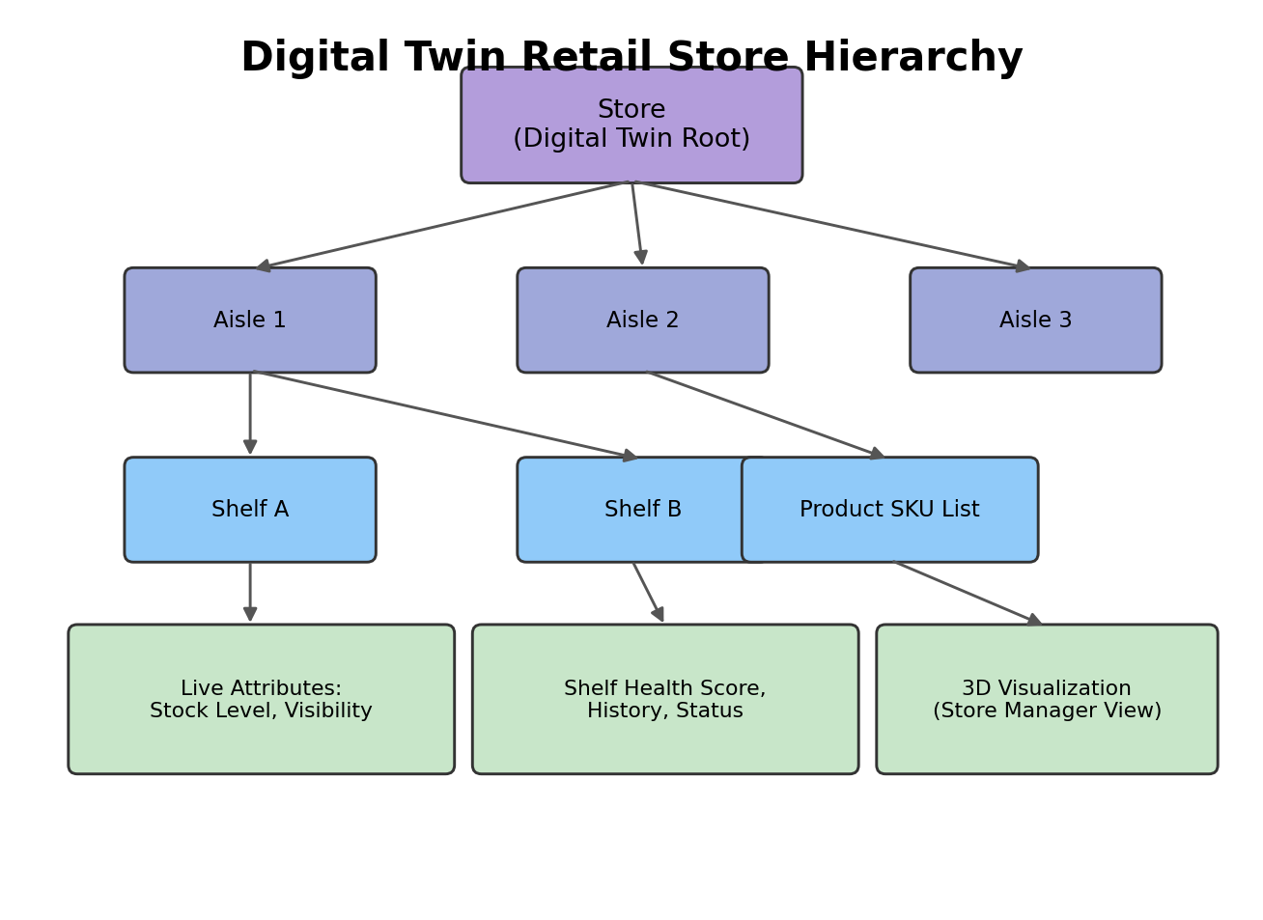

12.2 Multi-Agent Architecture

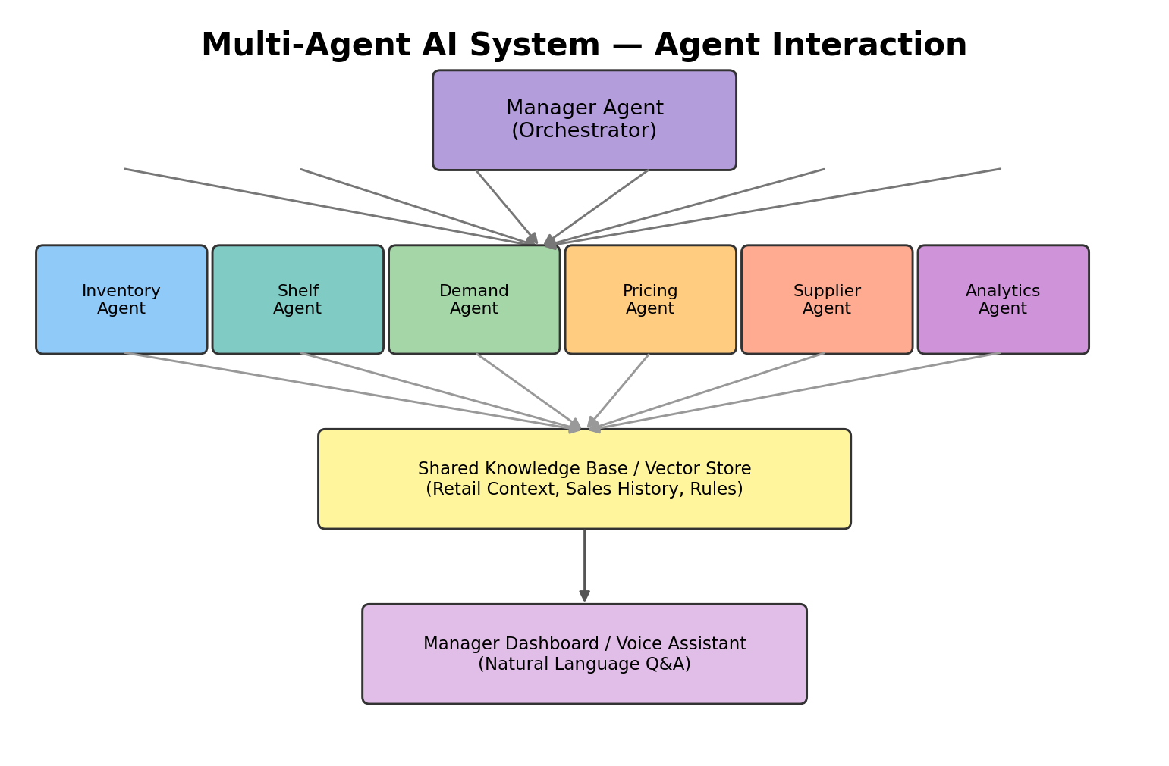

13. SDLC / Development Methodology

Methodology | Characteristics | Fit for this project
Waterfall | Rigid, no iteration | Poor fit — requirements evolve with AI model tuning
Spiral | Risk-driven but heavy documentation | Overhead too high for a lean student/startup team
Scrum | Iterative, fixed sprints | Good fit but rigid ceremony overhead
Kanban | Continuous flow, visual | Good for maintenance, weak for structured MVP delivery
DevOps | CI/CD, automation focus | Complements Agile; not a full methodology alone
Agile (chosen) | Iterative, adaptive, incremental delivery | Best fit — enables rapid AI-model iteration and stakeholder feedback loops

Agile (Scrum + DevOps practices) is selected because the AI-detection accuracy will require continuous iteration based on real shelf feedback, and CI/CD pipelines enable rapid, safe deployment across pilot stores.

13.1 Development Phases

- Phase 1: Requirement gathering & pilot aisle selection
- Phase 2: Data collection & edge hardware setup
- Phase 3: AI model training (detection, OCR, forecasting)
- Phase 4: Backend/API and database development
- Phase 5: Dashboard & agentic assistant integration
- Phase 6: Pilot deployment & staff feedback loop
- Phase 7: Full store rollout & continuous improvement

14. Expected Outcomes
Business Impact: Reduced stockout-driven revenue loss, optimized inventory holding cost, faster replenishment cycles.
Technical Impact: Reusable AI/CV pipeline extensible to other verticals (pharmacy, warehouse).
Customer Impact: Higher product availability and improved in-store experience.
ROI: Pilot-stage cost recovered through reduced stockout losses and labour reallocation within an estimated 12-18 months, with incremental ROI improving as the system scales across stores.

15. Risks & Limitations

Category | Risk | Mitigation
Technical | Sensor/network failure | Redundant edge caching, offline sync
AI Accuracy | False detections causing wrong reorders | Human-in-loop validation, self-learning retraining
Privacy | Camera footage of customers | On-device blurring, no facial data retention
Security | Unauthorized data access | RBAC, encryption, audit logs
Cost | High initial hardware investment | Phased rollout starting with pilot aisle
Operational | Staff resistance to new workflow | Training, intuitive UI, gradual rollout
Ethical/Legal | Surveillance concerns | Transparent policy, compliance with data laws
Deployment | Store network variability | Edge-first design reduces cloud dependency

16. Future Enhancements
- Drone-based night inventory scanning for large stores
- Robotic autonomous restocking arms
- AR glasses for staff restocking guidance
- Digital Shelf Passport with full lifecycle history
- Customer heatmap-driven planogram optimization
- Dynamic AI-based pricing engine
- Voice-first multilingual manager assistant
- Federated learning across store chains for privacy-safe model improvement
- Blockchain-based supplier traceability
- Computer-vision-based queue/checkout analytics
- Sustainability tracking (spoilage, energy use)
- Predictive maintenance for IoT sensor fleet
- Automated planogram compliance scoring
- Cross-store inventory rebalancing recommendations
- Integration with smart carts/RFID trolleys
- AI-generated promotional layout suggestions
- Real-time competitor price monitoring integration
- Mobile app for customer live stock lookup
- Advanced anomaly detection using multimodal LLMs
- Carbon-footprint-aware supply chain optimization

17. Conclusion
SmartRetail Vision demonstrates that a modular, edge-first, multi-agent AI architecture can practically resolve long-standing retail inventory visibility gaps. By fusing multi-sensor data into a live Digital Twin and layering predictive and agentic intelligence on top, the system converts a traditionally manual, reactive process into a proactive, automated, and explainable one — delivering measurable business value while remaining feasible to pilot within realistic budget and infrastructure constraints.

18. Bonus Content

18.1 Assumptions
- Stores have stable Wi-Fi/LAN for edge-to-cloud sync.
- Product catalog/SKU master data is available via existing ERP.
- Store management is willing to install shelf-level sensors/cameras.

18.2 Constraints
- Limited hardware budget for full-store sensor coverage in pilot phase.
- Real-time performance dependent on edge device compute limits.

18.3 Success Metrics (KPIs)
- Stockout reduction %
- Shelf audit time reduction %
- Replenishment cycle time
- Detection accuracy (mAP)
- Shelf health score improvement trend

18.4 SWOT Analysis

Factor | Detail
Strengths | Real-time automation, modular AI architecture
Weaknesses | High initial hardware cost, dependency on model accuracy
Opportunities | Expansion to warehouses, pharmacies, multi-store chains
Threats | Competing vendor solutions, evolving privacy regulation

18.5 Feasibility Analysis
- Technical: Proven CV/IoT technologies, mature open-source tooling.
- Operational: Requires staff training but minimal workflow disruption.
- Economic: Positive ROI achievable via phased rollout.
- Schedule: Pilot deployable within 4-6 months using Agile phases.

18.6 Glossary
- SKU – Stock Keeping Unit
- OCR – Optical Character Recognition
- RFID – Radio Frequency Identification
- BLE – Bluetooth Low Energy
- ERP – Enterprise Resource Planning
- POS – Point of Sale
- mAP – mean Average Precision (detection accuracy metric)

